H.T No
Regulations:
A15

Sreenidhi Institute of Science and Technology
(An Autonomous Institution)
Code No: 5B730 Date: 05-July-2023 (AN)

B.Tech IV-Year I- Semester External Examination, July - 2023 (Supplementary)
Finite Element Method (ME)

Time: 3 Hours Max.Marks:75

Note: a) No additional answer sheets will be provided.
b) All sub-parts of a question must be answered at one place only, otherwise it will not be valued.
c) Missing data can be assumed suitably.
Bloom's Cognitive Levels of Learning (BCLL)

Remember | L1 | Apply | L3 | Evaluate | L5
Understand | L2 | Analyze | L4 | Create | L6

Part - A Max.Marks:25
Answer all QUESTIONS

 |  | BCLL | CO(s) | Marks
1 | What are the properties of shape functions? | L1 | CO1 | [2M]
2 | Mention the stiffness matrix for beam element. | L2 | CO2 | [2M]
3 | Write short notes on 2-D elements in FEM. | L2 | CO3 | [2M]
4 | Briefly explain iso-parametric formulation. | L2 | CO4 | [2M]
5 | List the boundary conditions of 1-D conduction heat transfer problems. | L2 | CO5 | [2M]
6 | List few FEA software packages. | L1 | CO6 | [3M]
7 | What are Hermite shape functions? | L2 | CO2 | [3M]
8 | Write a short note on Quadrilateral elements available in FEM. | L2 | CO4 | [3M]
9 | What is geometric isotropy in FEM? | L1 | CO6 | [3M]
10 | Mention the properties of stiffness matrix. | L2 | CO1 | [3M]
Part – B Max.Marks:50
ANSWER ANY FIVE QUESTIONS. EACH QUESTION CARRIES 10 MARKS.

 |  |  | BCLL | CO(s) | Marks
11. |  | A structure consists of two bars. An axial load P = 200 KN is applied as shown in the figure. Determine the following;  - Nodal Displacements  - Reactions forces  - Element stresses  Take A₁ = 2400 mm², E₁ = 70*10³ N/mm², A₂ = 600 mm², E₂ = 200*10³ N/mm²  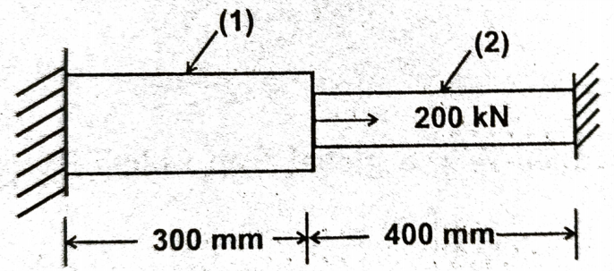 | L3 | CO1 | [10M]
12. |  | A beam fixed at one end and supported by a roller at the other end has a 20KN load applied at the centre of the span, as shown below. Calculate the deflection under the load.  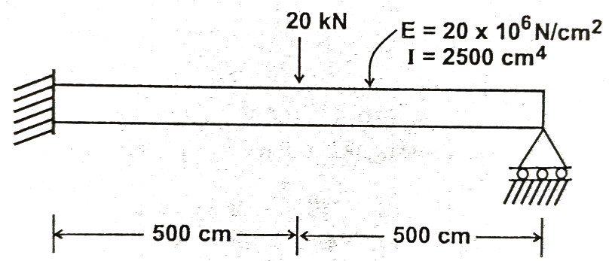 | L3 | CO2 | [10M]
13. |  | Evaluate the element stiffness matrix for a constant strain triangle element with nodal coordinates; x₁ = 2, x₂ = 6, x₃ = 4 & y₁ = 2, y₂ = 4, y₃ = 6. Assume plane strain condition, E = 200 GPa, μ = 0.3 and thickness = 3 mm. | L3 | CO3 | [10M]
14. | a) | Find the integral I = using Gaussian Quadrature method | L3 | CO4 | [5M]
 | b) | Elaborate on the 3-D elements available in FEM. | L2 | CO4 | [5M]
15. |  | A wall of 0.5m thickness has thermal conductivity of 6 W/mK. The wall is insulated with a material of thickness 0.1m having an average thermal conductivity of 0.3 W/mK. The inner surface temperature is 1200⁰C and the outside of the insulation is exposed to atmospheric air at 30⁰C with heat transfer coefficient of 40 W/m²K. Calculate the nodal temperatures.  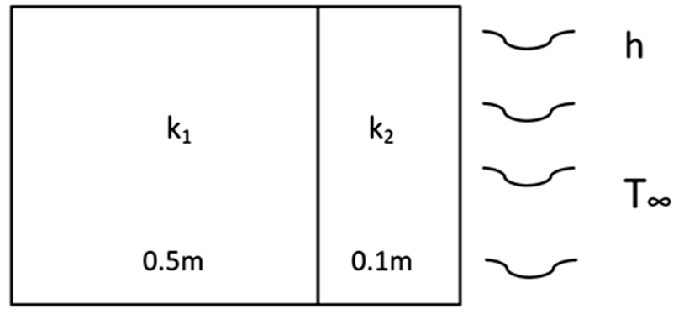 | L4 | CO5 | [10M]
16. |  | Determine the Eigen values and natural frequencies for the stepped bar shown below. Assume E = 30*10¹⁰ N/m² and ρ = 8500 kg/m³.  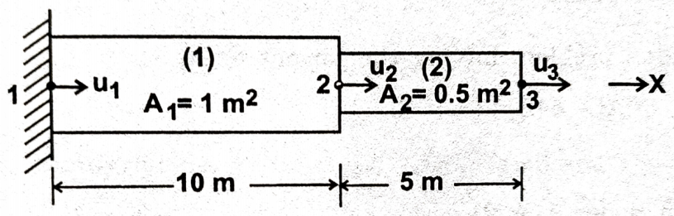 | L3 | CO6 | [10M]
17. | a) | Mention the applications and advantages of FEM? | L2 | CO1 | [4M]
 | b) | Mention the stiffness matrix for a plane truss element with two nodes. | L3 | CO2 | [3M]
 | c) | Differentiate the CST and LST elements used in FEM. | L3 | CO3 | [3M]
18. | a) | Briefly explain the concept of numerical integration. | L2 | CO4 | [4M]
 | b) | Mention the FE equation for 1-D heat conduction problem with edge surface convection. | L2 | CO5 | [3M]
 | c) | Elaborate on the types of errors in FEM. | L1 | CO6 | [3M]

-- 00 -- 00 –

